**Fundchain- a crowd funding website on blockchain**

***Submitted by***

**Ubaid Ahmed (2020-310-231)**

***in partial fulfillment for the award of the degree of***

**BTECH in Computer Science and Engineering**

***Under the supervision of***

**Mrs. ASFIYA AZIZ**

**Department of Computer Science**

**JAMIA HAMDARD**

**(Hamdard University)**

**New Delhi-110062**

**(2023)**

DECLARATION

I, **Mr. Ubaid Ahmed** a student of **BTECH in Computer Science and Engineering, (Enrolment No:2020-310-231)** hereby declare that the dissertation entitled “**Fundchain-A crowd funding website which makes use of blockchain and smart contracts”** which is being submitted by me to the Department of Computer Science, Jamia Hamdard, New Delhi in partial fulfillment of the requirement for the award of the degree of **BTECH-CSE ,** is my original work and has not been submitted anywhere else for the award of any Degree, Diploma, Associateship, Fellowship or other similar title or recognition.

**Ubaid Ahmed**

**Date: 17th November,2023**

**Place: Jamia Hamdard University**

**ACKNOWLEDGEMENT**

I would like to express my special thanks of gratitude to our Professor **Mrs. Asfiya Aziz** who gave me the golden opportunity to do this wonderful project on “**Fundchain-A crowd funding website which makes use of blockchain and smart contracts”** which also helped me in doing a lot of research and I came to know about so many new things.

**Date:17th November,2023 Ubaid Ahmed**

**INDEX**

|  |  |  |
| --- | --- | --- |
| **S. No** | **Topic** | **Page no.** |
| **1** | **INTRODUCTION** | **5-9** |
| **2** | **PROJECT STRUCTURE** | **10-11** |
| **3** | **PROJECT WORKFLOW DEMO SCREENSHOTS** | **12-19** |
| **4** | **ER MODEL AND DATA FLOW DIAGRAM** | **20-21** |
| **5** | **CONCLUSIONS AND FUTURE SCOPE** | **22-23** |
| **6** | **REFERENCE** | **24** |

**INTRODUCTION**

Blockchain is a transformative technology that has the potential to revolutionize the way we conduct business and exchange value. At its core, blockchain is a decentralized, distributed ledger technology that allows for the secure, transparent, and immutable recording of transactions. This makes it highly resistant to tampering, hacking, and fraud, as all participants on the network must agree on any changes or updates to the ledger.

While blockchain is most associated with cryptocurrencies like Bitcoin, its applications extend far beyond finance. For example, it has the potential to transform supply chain management by providing a transparent and traceable record of products from manufacturer to consumer. It can also enable digital identity verification, reducing fraud and streamlining processes in a wide range of industries.

In addition to its technical capabilities, blockchain represents a fundamental shift in the way we think about trust and authority. By removing the need for intermediaries such as banks or government agencies, blockchain empowers individuals and organizations to interact and transact with greater autonomy and security.

As blockchain continues to evolve and mature, we can expect to see it play an increasingly important role in shaping the future of business and society. From improving financial inclusion to advancing environmental sustainability, the possibilities for blockchain are truly limitless.

One such use of blockchain is for storing data, as blockchain are mainly used to store data about the various transactions, in this project we are storing user written blogs on the demo blockchain.

**1.1)PROBLEM STATEMENT**

The advent of blockchain technology has ushered in a new era of decentralized financial systems, providing innovative solutions to traditional challenges. One such challenge lies in the realm of crowdfunding, where transparency, security, and trust are paramount. Traditional crowdfunding platforms often face issues related to mismanagement of funds, lack of accountability, and delayed disbursements, leading to a breakdown in trust between project creators and investors. Additionally, the centralized nature of these platforms raises concerns about potential fraud and misuse of raised funds.

To address these issues, the proposed project aims to leverage smart contract technology, a cornerstone of blockchain innovation, to create a crowdfunding platform with enhanced security and transparency. By implementing a smart contract system, funds contributed by investors are securely stored in an incorruptible and transparent ledger. The smart contract's programmable features allow for a conditional release of funds, ensuring that withdrawals can only be made with the explicit approval of the investors. This not only mitigates the risk of mismanagement but also establishes a democratic and trust-based framework, where the control over financial transactions is decentralized among the contributors.

In summary, the problem at hand is the prevalent lack of trust and accountability in traditional crowdfunding platforms, and the proposed solution involves harnessing blockchain's smart contract capabilities to create a transparent, secure, and democratic crowdfunding ecosystem. This innovative approach aims to revolutionize the crowdfunding landscape by instilling confidence among investors, project creators, and other stakeholders, ultimately fostering a more robust and reliable crowdfunding experience.

**1.2)OBJECTIVE:**

The objective of this project is to understand the basic functionality of blockchain, i.e. to provide a high level understanding of what the blockchain is. How does the blockchain operates. Why is it considered to be a safer option than the traditional internet?

The primary aim of this report is to offer a comprehensive analysis of our crowdfunding website project, emphasizing the pivotal role played by smart contracts in facilitating secure and transparent fund management. Throughout the document, we will delve into the project's overarching objectives, detailing the technical architecture employed, challenges faced, and the innovative solutions implemented to ensure the seamless integration of smart contracts into our platform. This report serves as a valuable resource for stakeholders and decision-makers, shedding light on the project's achievements, key features, and the transformative impact it has had on modernizing online fundraising.

Furthermore, the report will provide an insightful evaluation of user experiences, emphasizing the user-friendly interface and the enhanced trust generated through the transparent handling of funds. In addition to celebrating successes, the report will critically examine challenges encountered during development, extracting valuable lessons learned. By presenting potential areas for future enhancement, the report aims to contribute to the ongoing evolution of the crowdfunding platform, ensuring its continued relevance and effectiveness in the dynamic landscape of online fundraising.

**PROJECT STRUCTURE**

The implementation of the project was done using JAVASCRIPT , HTML ,CSS. All the data have been stored using MongoDB. MongoDB is a non-relational document database.

Index.js is the entry point of the project. It imports express.js. Express.js is a framework built on top of node.js which helps in managing server and routes.

EJS has been used as a templating language to render dynamic web pages which can display variable data.

Index.js imports different parts of the program from different directories which are all stored in a root directory and takes care of the routing of the different pages for the frontend.

Solidity has been used to write the smart contract. Solidity is the sole programming language developed by the developers of Ethereum blockchain to write smart contracts in.

Truffle has been used to deploy and compile the smart contracts. Truffle is JAVASCRIPT framework used to compile, deploy smart contracts and to connect with a blockchain network.

Web3.JS has been used to connect the front-end of the website with the smart contract.

Mongoose has been used to connect the javascript file with the mongoDB database.

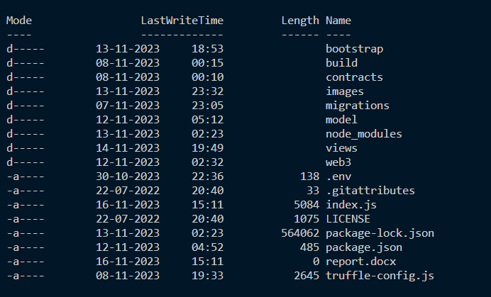

List of all the dependencies

**PROJECT WORKFLOW**

**3.1)FRONT-END**

The starting point of the project is the home page of the funding website since the website is being hosted locally via node.js. The URL for the home page is localhost:230/Home. The home page serves as the greeting page or the users as well as provides a brief introduction of the project.

The second page the user will interact with is the login/signup page here the user enters the username, password and the address of their matemask account to create a new account or login to exit the account.

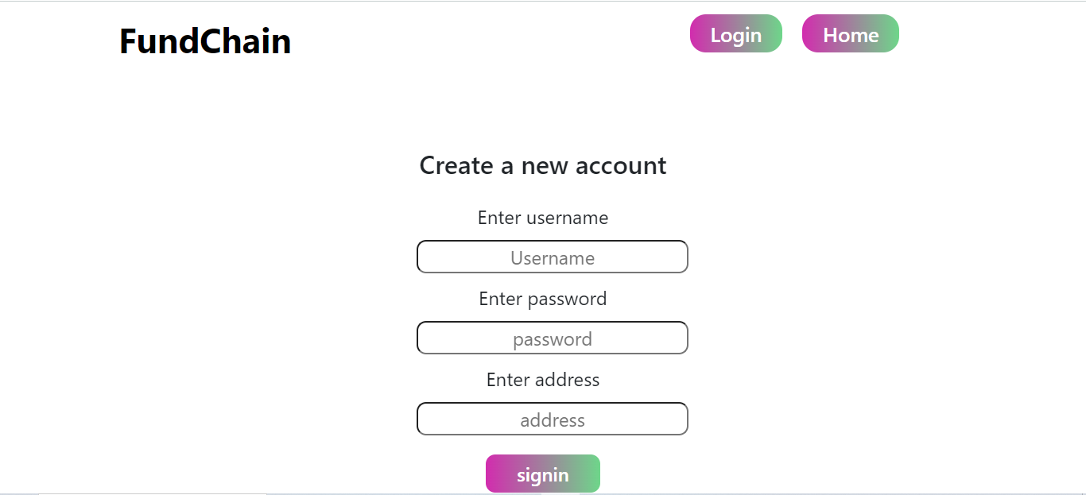

Once the user is logged in the account the website displays the username at the top right, and all the proposal the user has proposed are displayed.

Clicking on the ***+***  button we will be redirected to the create proposal web page which take information regarding the proposal.

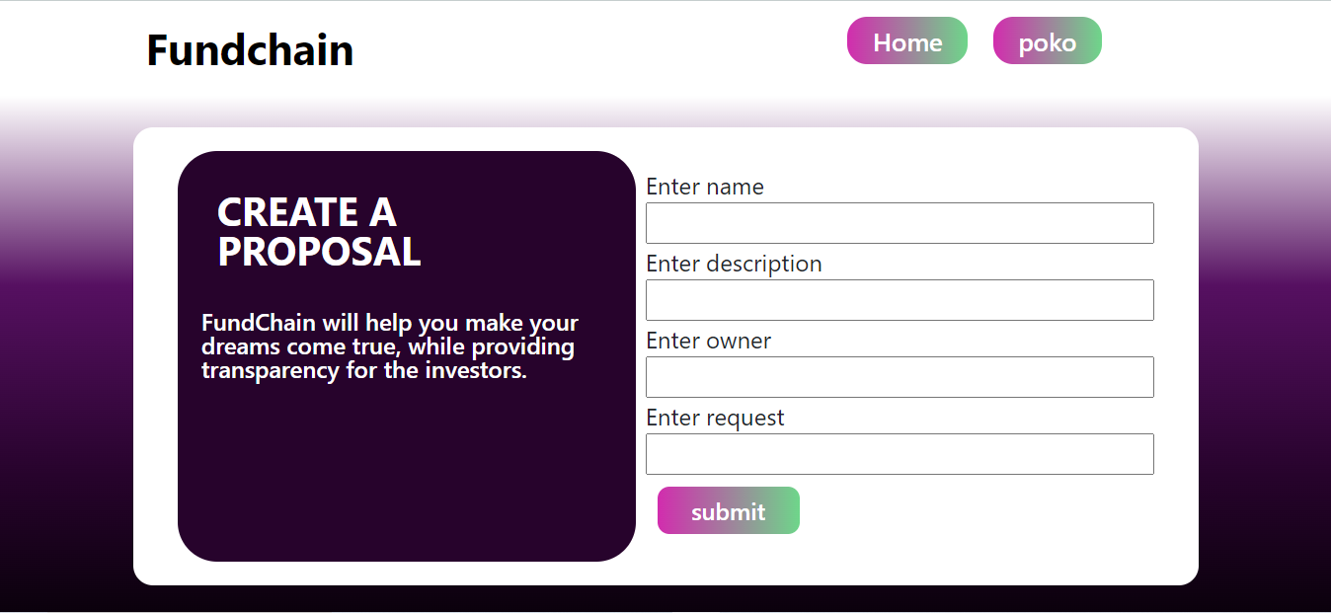

Once the proposal has been created, it information will be displayed to the main page to the user along with the rest of the proposals the user have created

**3.2)BACK-END**

Truffle is a JAVASCRIPT library used to compile and deploy smart contracts as well as provide a connection with the blockchain. For the purpose of the project, I have made use of Ganache, a free application which provides the user with a fake blockchain and a bunch of accounts with fake ether. The smart contract was deployed on truffle. While being deployed the address of the account deploying the contract will be stored in a variable ‘manger’. Only the manager account can transfer the funds from the smart contract to the account requesting for money.

The data of the user and the details of the proposal are shared in the mongoDB database. MongoDB creates and unique id for each of the document objects which are stored in the database.

**ER MODEL**

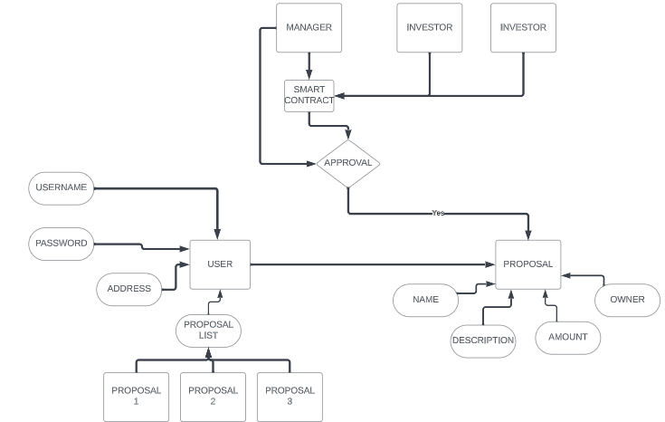

**DFD**

**CONCLUSION**

In conclusion, the development of a crowdfunding platform utilizing smart contract technology represents a significant stride towards addressing the inherent challenges within traditional crowdfunding models. The innovative integration of blockchain not only enhances transparency and security but also fundamentally transforms the dynamics of trust within the fundraising ecosystem. By shifting control to a decentralized network of investors through programmable and conditional fund releases, the proposed platform seeks to eradicate longstanding issues such as mismanagement, delayed disbursements, and potential fraud.

This project stands at the intersection of financial technology and decentralized systems, offering a promising solution to the trust deficit that has plagued conventional crowdfunding platforms. The adoption of smart contracts ensures an immutable and auditable ledger, instilling confidence among investors and project creators alike. The envisioned crowdfunding model has the potential to redefine industry standards, providing a more democratic and secure fundraising experience. As we embrace the power of blockchain technology to revolutionize financial transactions, this project exemplifies a forward-looking approach to crowdfunding, fostering an ecosystem where transparency, accountability, and trust converge for the benefit of all stakeholders involved.

**FUTURE SCOPE**

The future scope of this project extends beyond its initial implementation, opening avenues for continuous refinement and expansion in tandem with emerging technologies. As blockchain and smart contract capabilities evolve, the crowdfunding platform can integrate additional features such as automated governance mechanisms, dynamic funding conditions, and enhanced tokenization. The integration of decentralized finance (DeFi) principles could further streamline financial processes, providing participants with increased flexibility and financial autonomy. Exploring interoperability with other blockchain networks and protocols could broaden the project's reach, fostering collaboration and compatibility within the larger blockchain ecosystem. Additionally, as regulatory frameworks for blockchain and cryptocurrencies continue to evolve globally, the project can adapt to ensure compliance and expand its accessibility to a wider user base. The scalability and adaptability of the proposed crowdfunding platform position it as a dynamic and forward-looking solution, poised to evolve in step with the rapidly changing landscape of blockchain technology and crowdfunding practices.

**REFERENCE**

* <https://www.youtube.com/watch?v=Oe421EPjeBEs>
* <https://www.youtube.com/watch?v=gyMwXuJrbJQ>
* <https://www.youtube.com/watch?v=7OR12WF2-3Y>